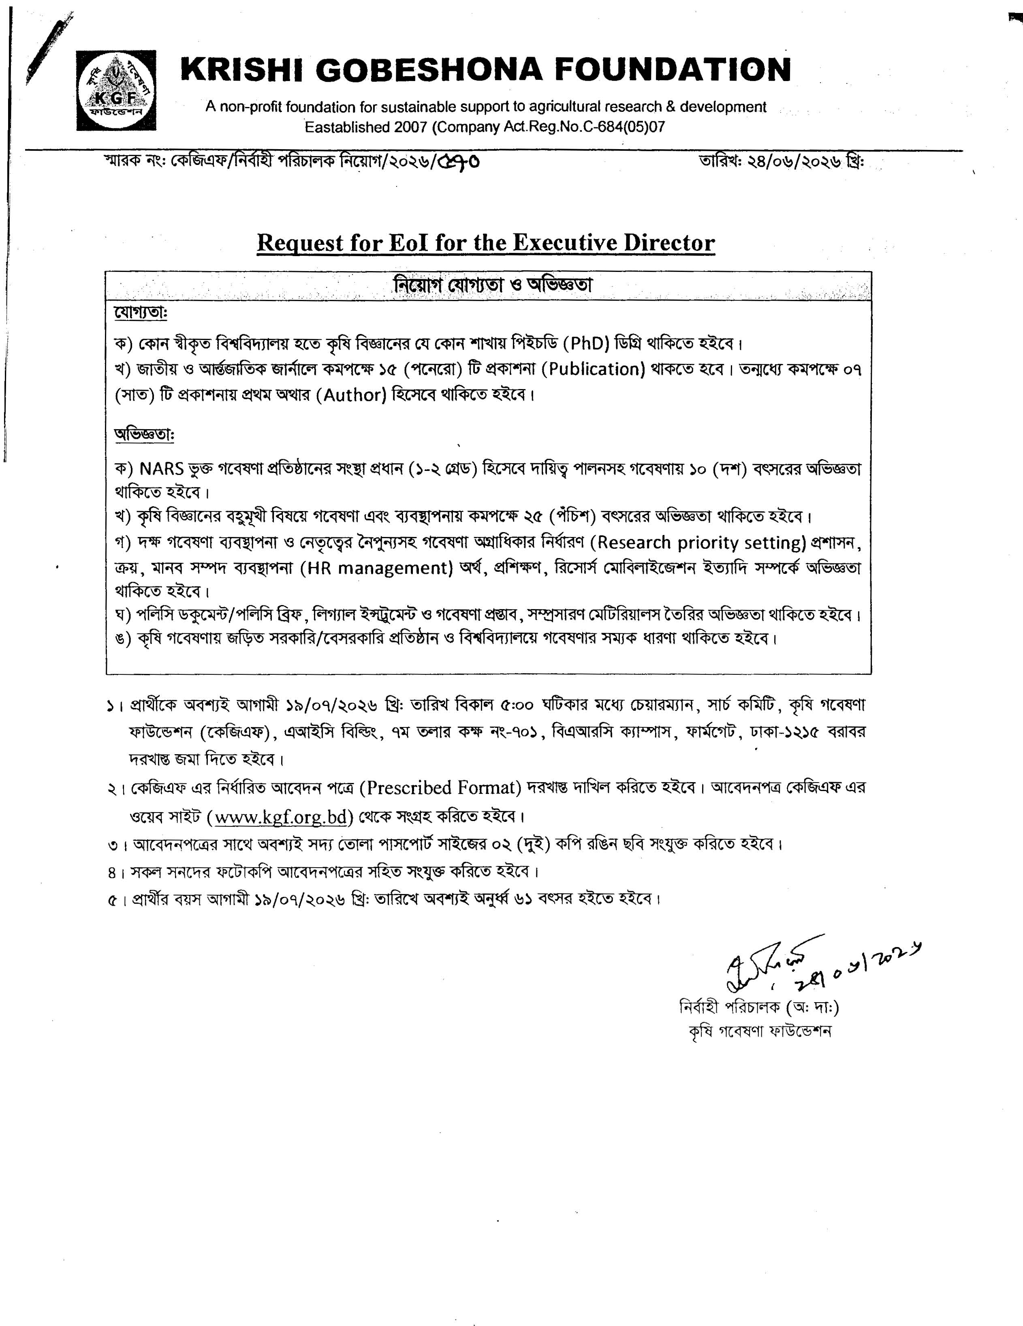

Attach Photograph
Application Submission Form for the Position of the
Executive Director (ED) of KGF

S/N | Applicant’s Information
1. | Name of the position for applied:
2. | Name of applicant:  Father’s Name:  Mother’s Name:
3. | Mailing address with contact no:
4. | Permanent Address:
5. | Date of Birth:
5. | Age on 19/07/2026 |  |  |  | Year: Month: Day:
6. | Nationality:  Religion:
7. | Membership of professional society:
8. | Academic qualification:
 | School/ college/university attended |  |  |  | Examination passed |  |  | Year |  |  | Division/Class/Grade (out of scale) obtained
9. | Training Received:
 | - In Country
 | i. | Name of Training | Duration (Days) |  |  | Institution & Country |  |  | Grade/Certificate/Diploma
 | ii.
 | iii.
 | iv.
 | v.
 | - Abroad/Overseas
 | vi.
 | vii.
 | viii.
 | ix.
 | x.
10. | Languages and degree of proficiency: (Excellent/Very good/Good)
 | Language |  |  |  | Speaking |  | Reading |  |  |  |  | Writing
11. | Employment/Service records (Employer/ Employers Organization Name):  (please attach a list of service records/experience from last to first position following the same style)
 |  |  |  | Employer 1
 |  |  |  | Designation:
 |  |  |  | Duration: |  |  |  | From: |  |  |  |  | To:
 |  |  |  | Description of the duties (Not more than eight)
 |  |  |  | i.
 |  |  |  | ii.
 |  |  |  | iii.
 |  |  |  | iv.
 |  |  |  | v.
 |  |  |  | Employer 2
 |  |  |  | Designation:
 |  |  |  | Duration: |  |  |  | From: |  |  |  |  | To:
 |  |  |  | Description of the duties (Not more than eight)
 |  |  |  | i.
 |  |  |  | ii.
 |  |  |  | iii.
 |  |  |  | iv.
 |  |  |  | v.
12. | Number of publications: (please attach a list of publication with photocopy of first page)
 | Scientific Papers:  As principal author:  - National  - International |  |  | As co-author:  - National  - International
 | Popular articles:
13. | Number of papers presented in different national & international seminars /symposiums/ workshops: (please attach a list of papers)
 | National: |  |  | International:
14. | Number of Projects prepared & implemented: (please attach a list of projects)
 | Projects prepared:
 | Projects implemented:
 | Policy Papers:
15. | Outstanding Achievements/Contributions:
16. | A brief write-up justifying applicant’s suitability for this position: within 250-300 words.
17. | Computer literacy:
18. | Certification:
18. | I, the undersigned, certify that to the best of my knowledge and belief, information provided in this application about myself, my qualifications and my experience are true. I also understand that any willful miss statement described herein may lead to my disqualification or dismissal, if engaged.  Signature:  Date :

